**User’s Manual**

**1 GENERAL INFORMATION**

This app provides an Android user with information on their battery usage. The app offers a list of apps using battery power, a graphical view of battery usage, and push notifications.

**2 Configure Settings**

**2.1 Set a Threshold**

The user can set a threshold on the settings page seen in Figure 1. The user can click and type in a battery percentage.

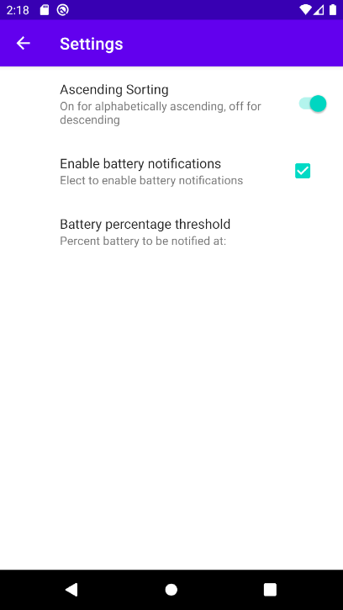

Figure 1 Settings Page

**2.2 Sort Alphabetically**

The user can toggle the sorting button to see their apps sorted either in alphabetical order or reverse alphabetical or

**2.3 Enable Notifications**

Notifications can be enabled by checking the box on the settings page as seen in figure 1.

**3 USING THE APP**

**3.1 Tracking battery level**

The user can track their current battery level by seeing the battery graphic bar on the main page (see figure 2).

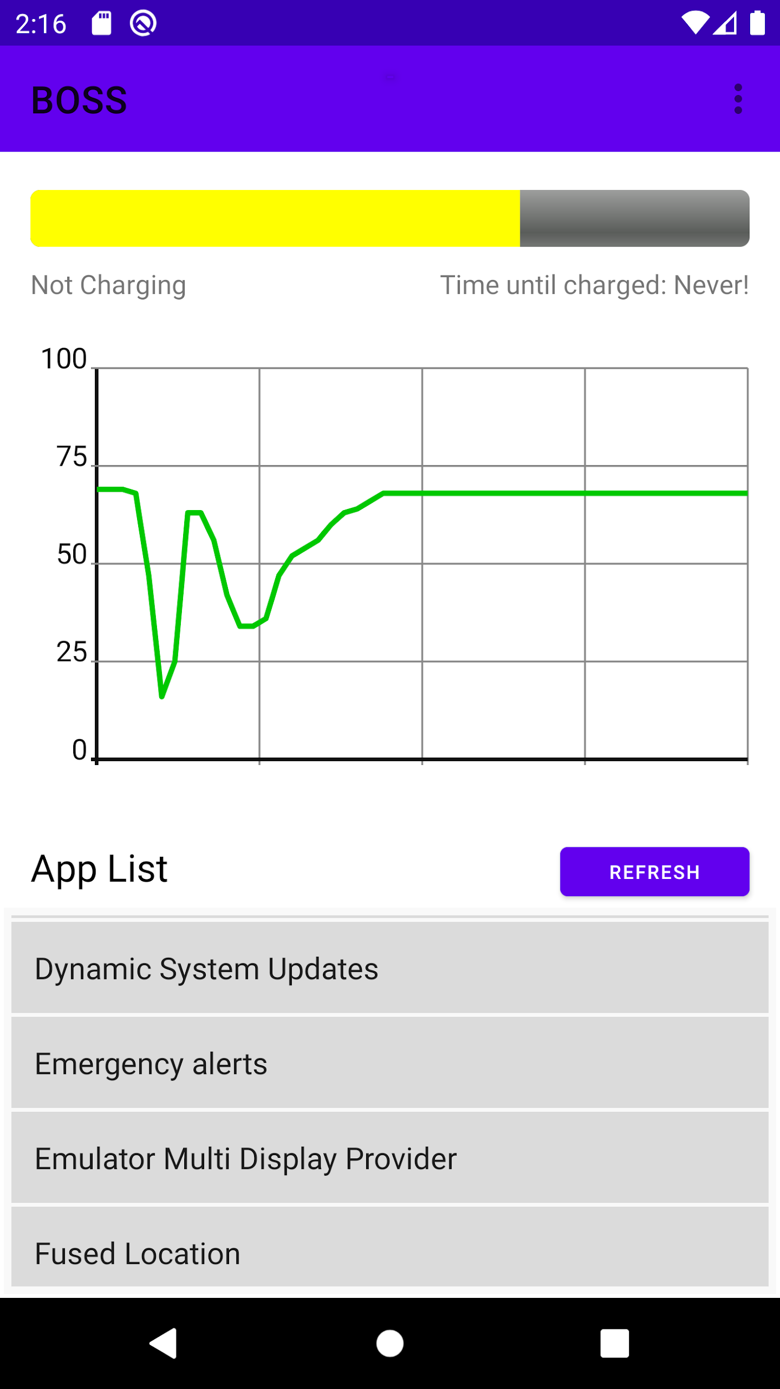

Figure 2 Home page

**3.2 Interpreting the Graph**

The graph shows the battery percentage on the y axis and the x axis represents time. The graph shows a dynamic representation of the user’s battery percentage over time.

**3.3 Refreshing the App List**

The user can click the “Refresh” button, as seen in Figure 2, to refresh the list of apps that are using battery.